**Task 1**

**Bug report**[**https://www.kmlvm.com.ua/**](https://www.kmlvm.com.ua/)

**mobile testing**

| Issue type | bug report 001 |
| --- | --- |
| Summary | The content of the page is covered by the carousel's buttons “next” and “previous”. |
| Environment | Iphone 11 Pro, iOS 16.2 |
| Steps to reproduce | 1. Open main page 2. Pay attention to the carousel's buttons “next” and “previous” |
| Actual result | The content of the page is covered by the carousel's buttons “next” and “previous”. |
| Expected result | The content of the page is not covered by the carousel's buttons “next” and “previous”. |

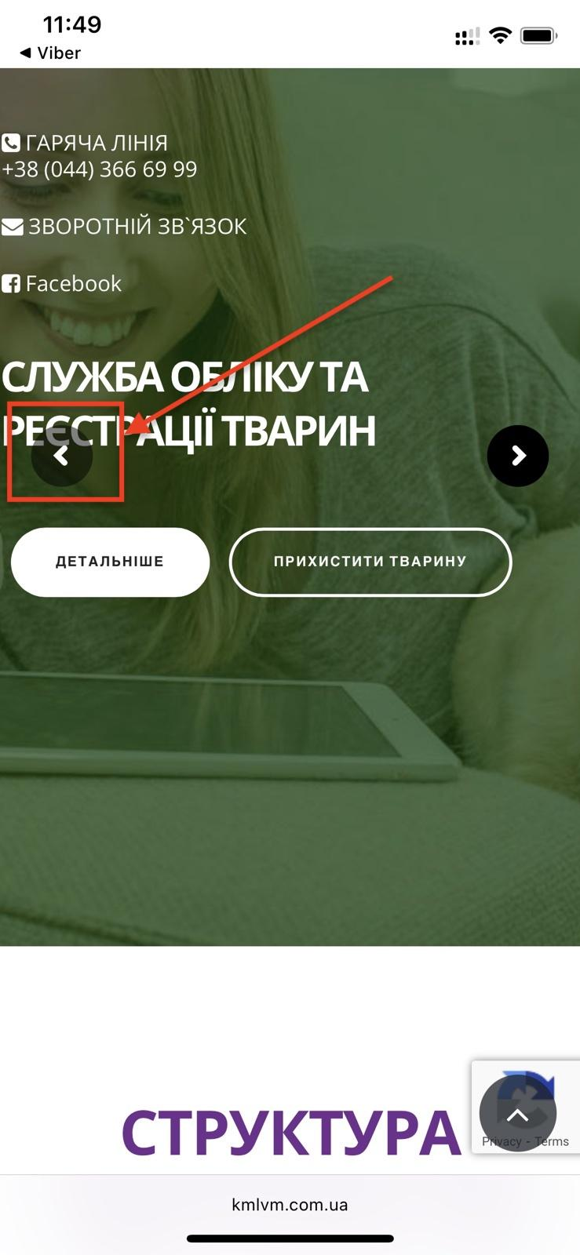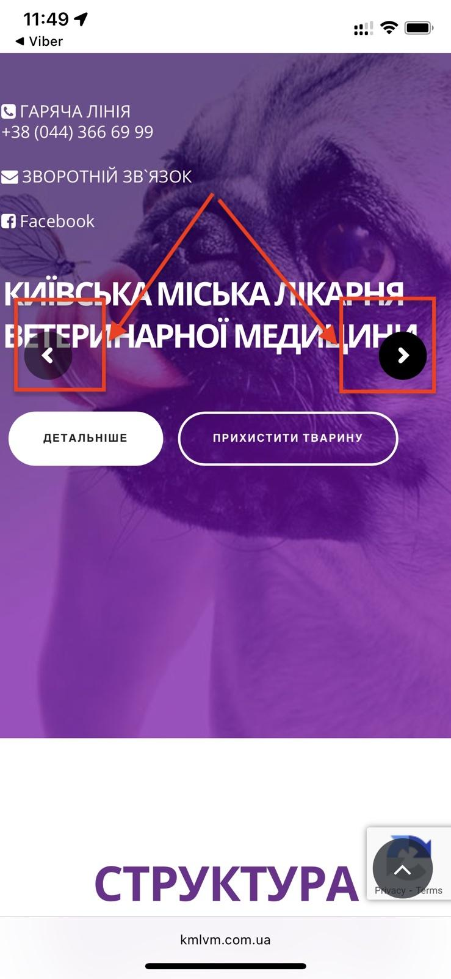

| Issue type | bug report 002 |
| --- | --- |
| Summary | The menu “БЛАГОДІЙНІСТЬ” in the footer of the site is not clickable. |
| Environment | Iphone 11 Pro, iOS 16.2 |
| Steps to reproduce | 1. Open main page 2. Scroll down to the footer 3. Pay attention menu “БЛАГОДІЙНІСТЬ” |
| Actual result | The menu “БЛАГОДІЙНІСТЬ” in the footer of the site is not clickable. |
| Expected result | The menu “БЛАГОДІЙНІСТЬ” in the footer of the site is clickable, the link must lead to the charity payment page. |

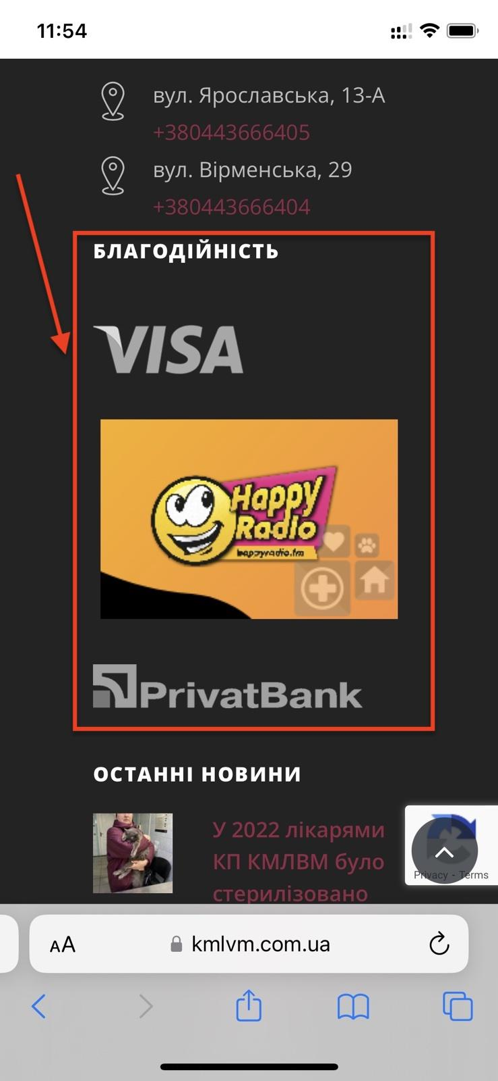

| Issue type | bug report 004 |
| --- | --- |
| Summary | The header and the fields of the contact form are not centralized. |
| Environment | Iphone 11 Pro, iOS 16.2 |
| Steps to reproduce | 1. Open main page <https://www.kmlvm.com.ua/contact-us/#contact> 2. Pay attention to the location of the header and the fields of the contact form |
| Actual result | The header and the fields of the contact form are not centralized. |
| Expected result | The header and the fields of the contact form are centralized. |

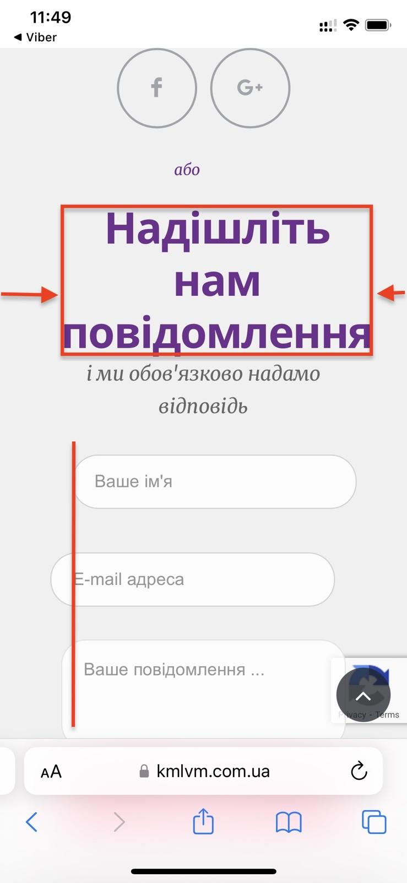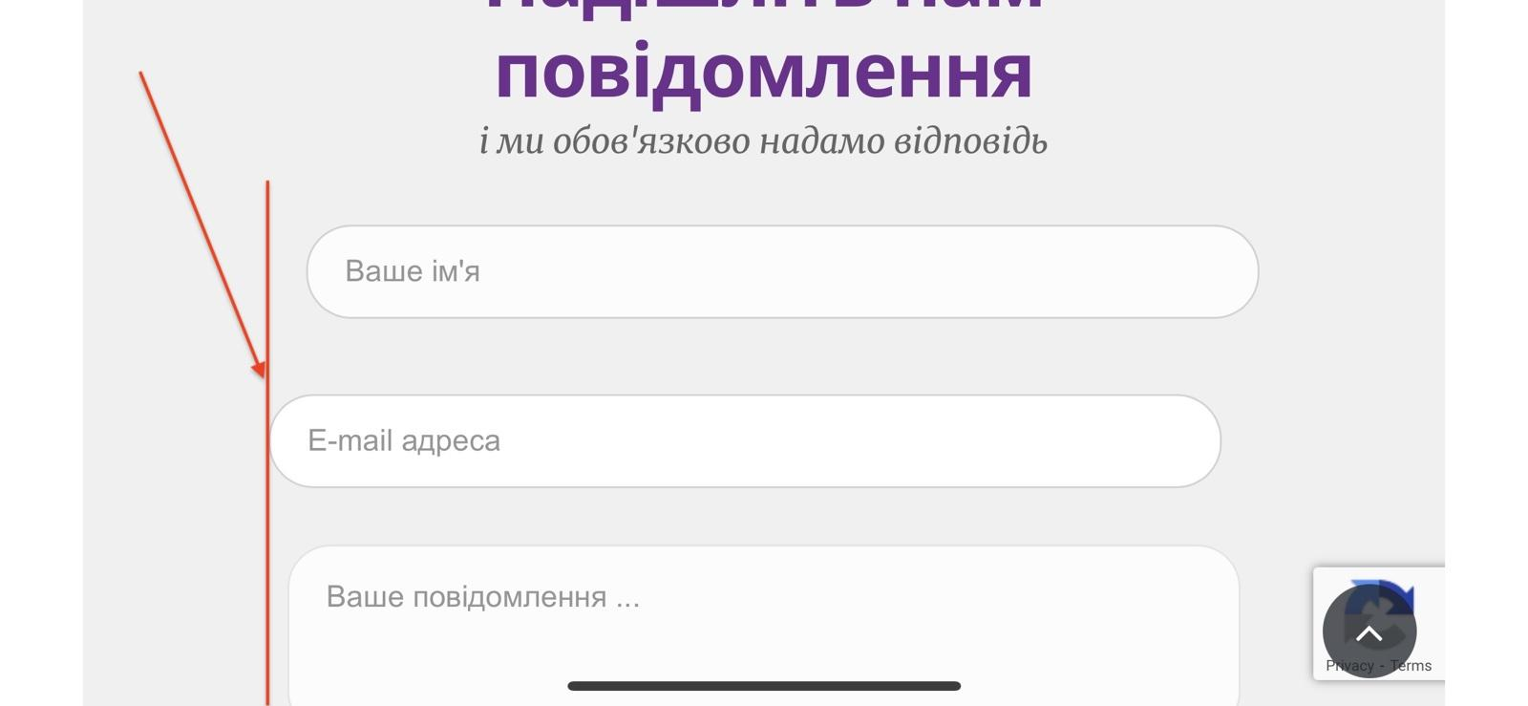

| Issue type | bug report 005 |
| --- | --- |
| Summary | The facebook icon leads to a broken or removed facebook page. |
| Environment | Iphone 11 Pro, iOS 16.2 |
| Steps to reproduce | 1. Go to <https://www.kmlvm.com.ua/contact-us/#contact> 2. Click Facebook icon |
| Actual result | The facebook icon leads to a broken or removed facebook page. |
| Expected result | The facebook icon leads to the **kmlvm** facebook page. |

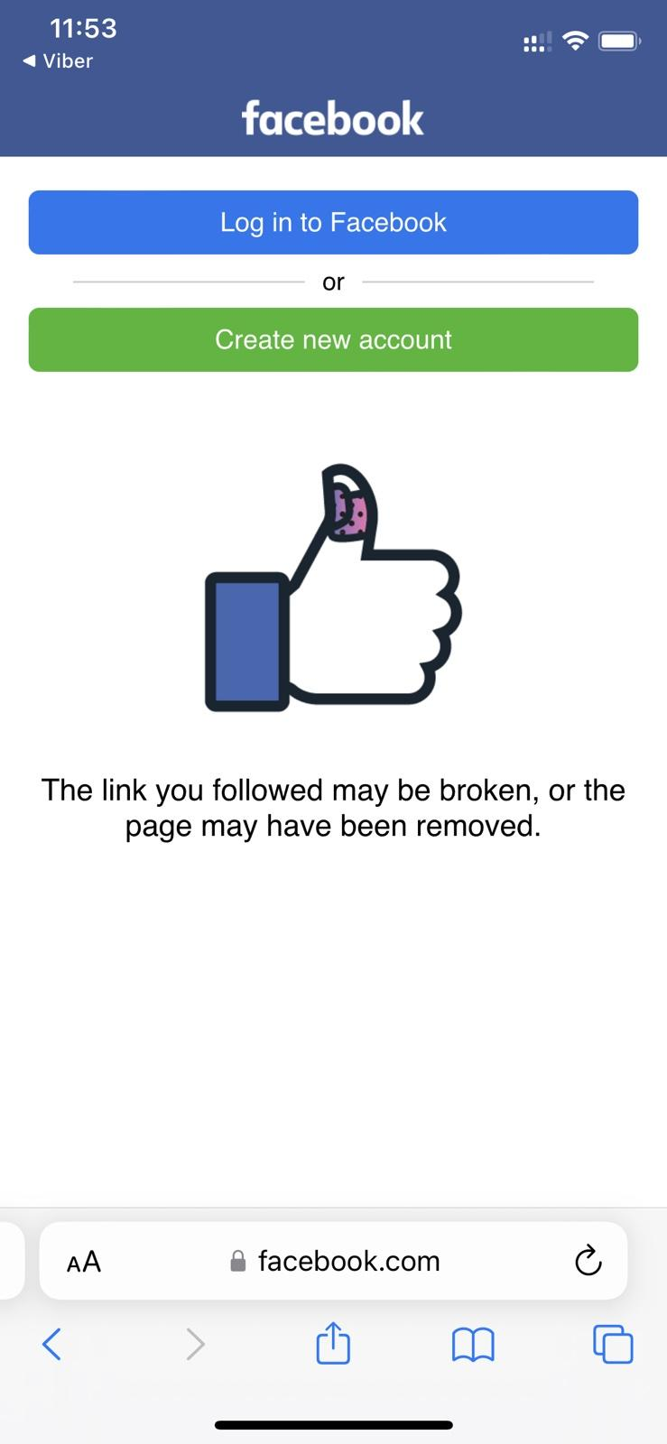

**Task 2**

| Issue type | bug report 006 |
| --- | --- |
| Summary | The phone link does not redirect to the call. |
| Environment | Iphone 14 Pro (simulator) |
| Steps to reproduce | 1. Go to <https://zpolis.com.ua> 2. Scroll down to the footer 3. Click phone number link |
| Actual result | The phone link does not redirect to the call.The system notifies with a massage “Safary cannot open the page because the address is invalid” |
| Expected result | The phone link must redirect to the call. |

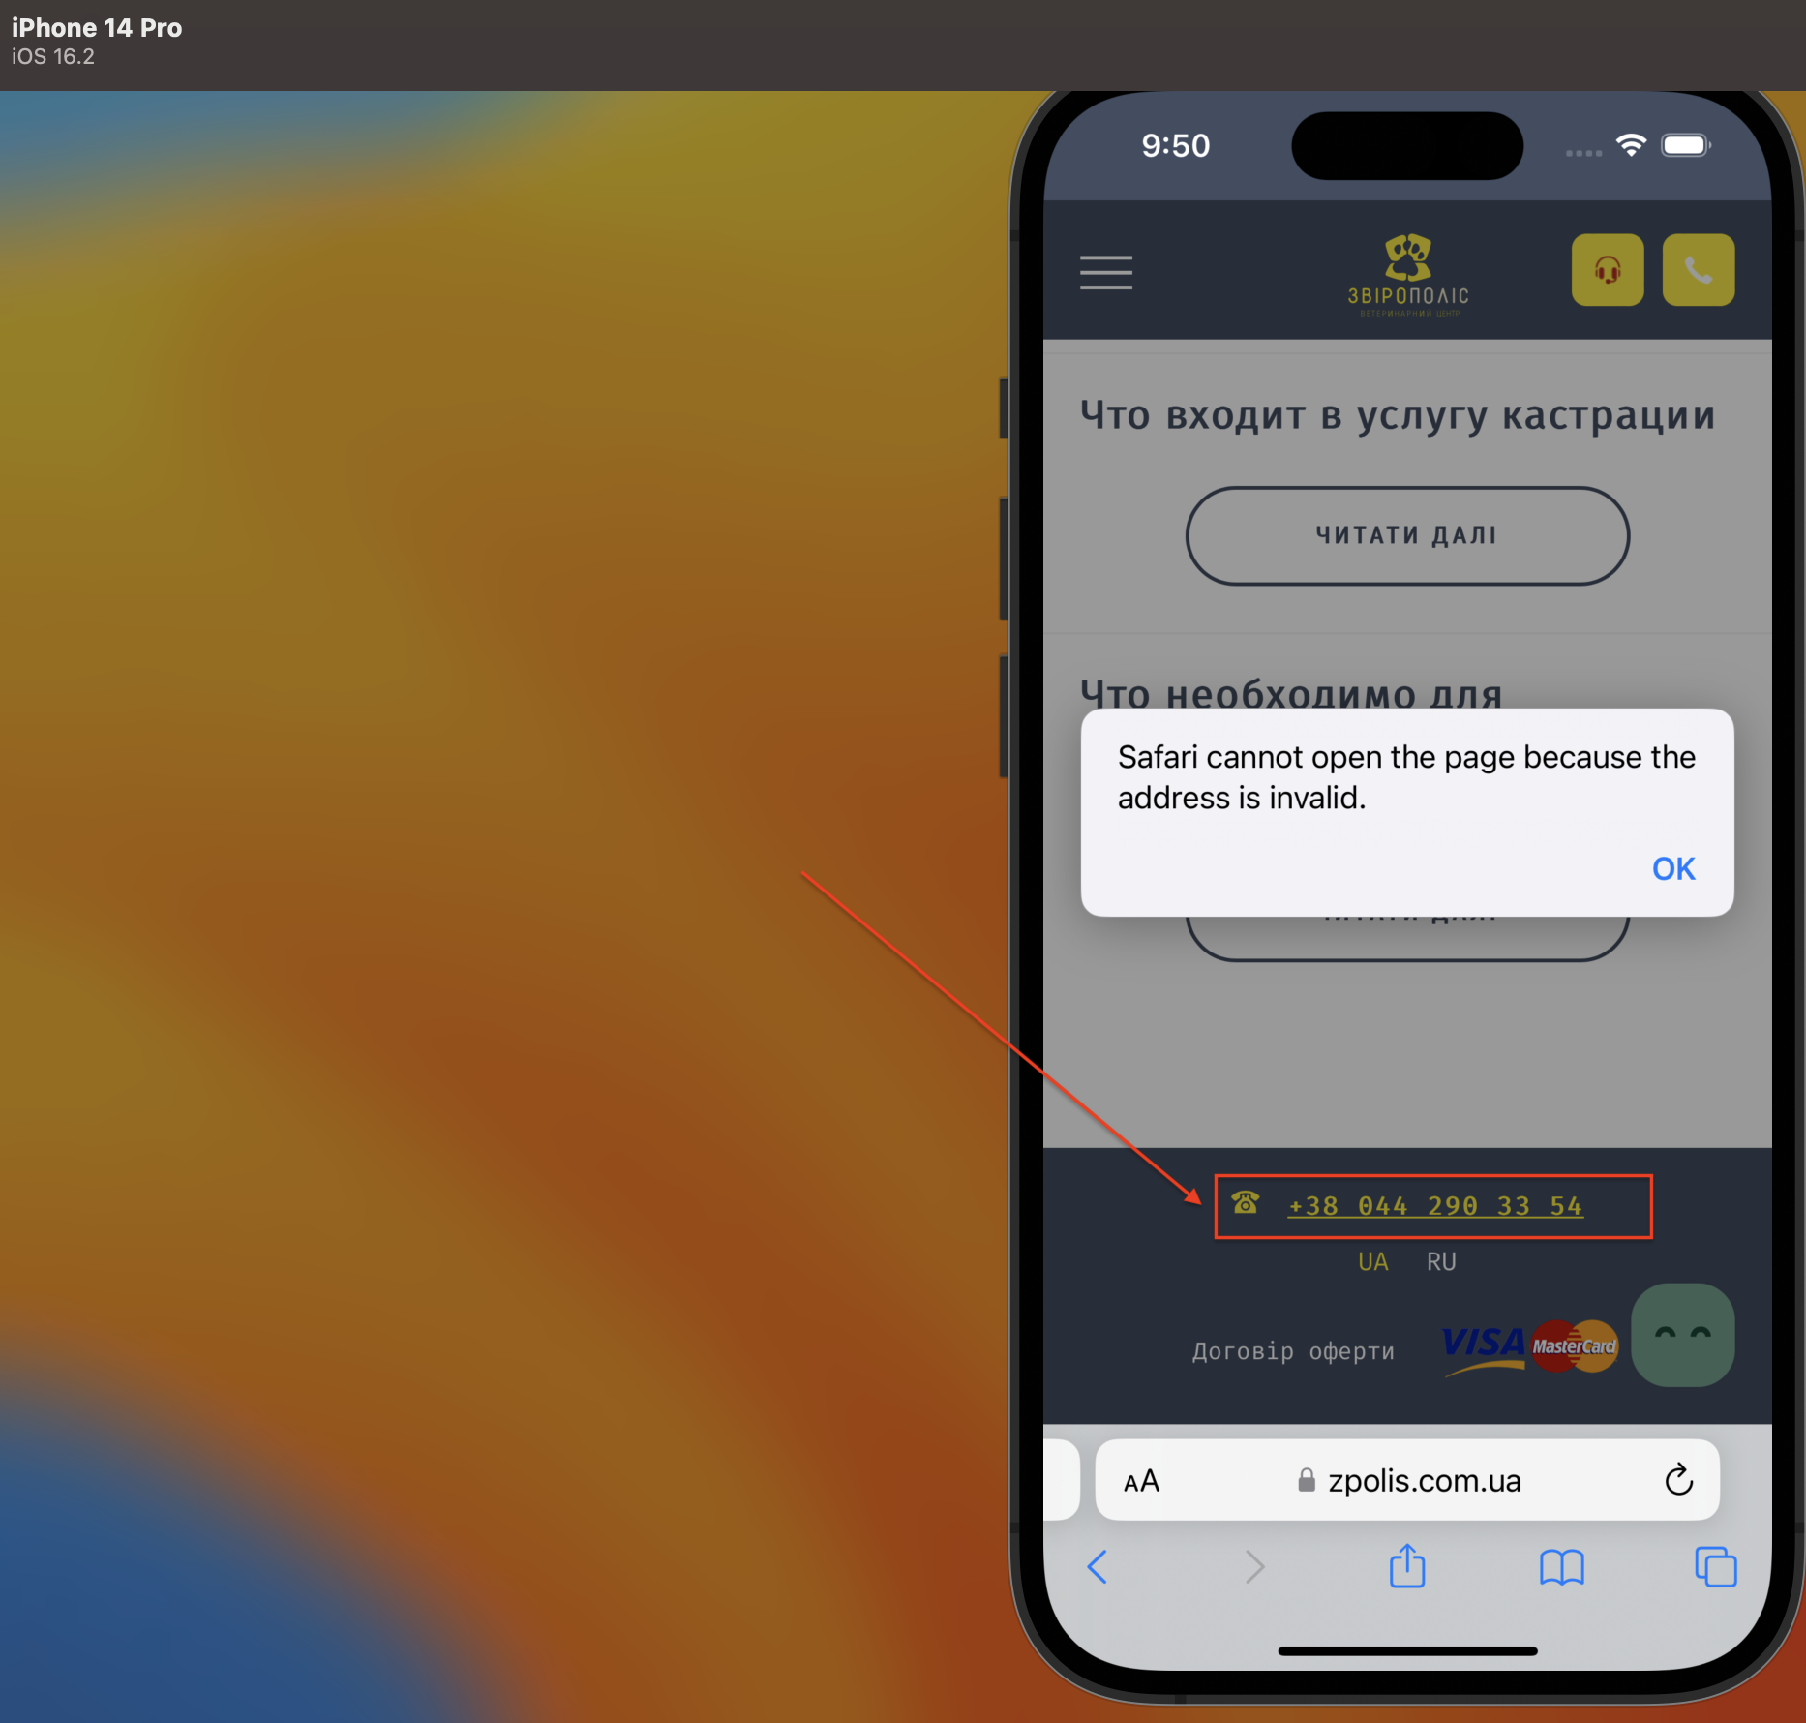

| Issue type | bug report 007 |
| --- | --- |
| Summary | The button caption contains closed quotes. |
| Environment | Iphone 14 Pro (simulator) |
| Steps to reproduce | 1. Go to <https://zpolis.com.ua> 2. Press the “Online consultation” icon in the header of the page. 3. Scroll down 4. Pay attention to the “Оплатити і записатись” button |
| Actual result | The button caption contains closed quotes. |
| Expected result | The button caption must not contain quotes. |

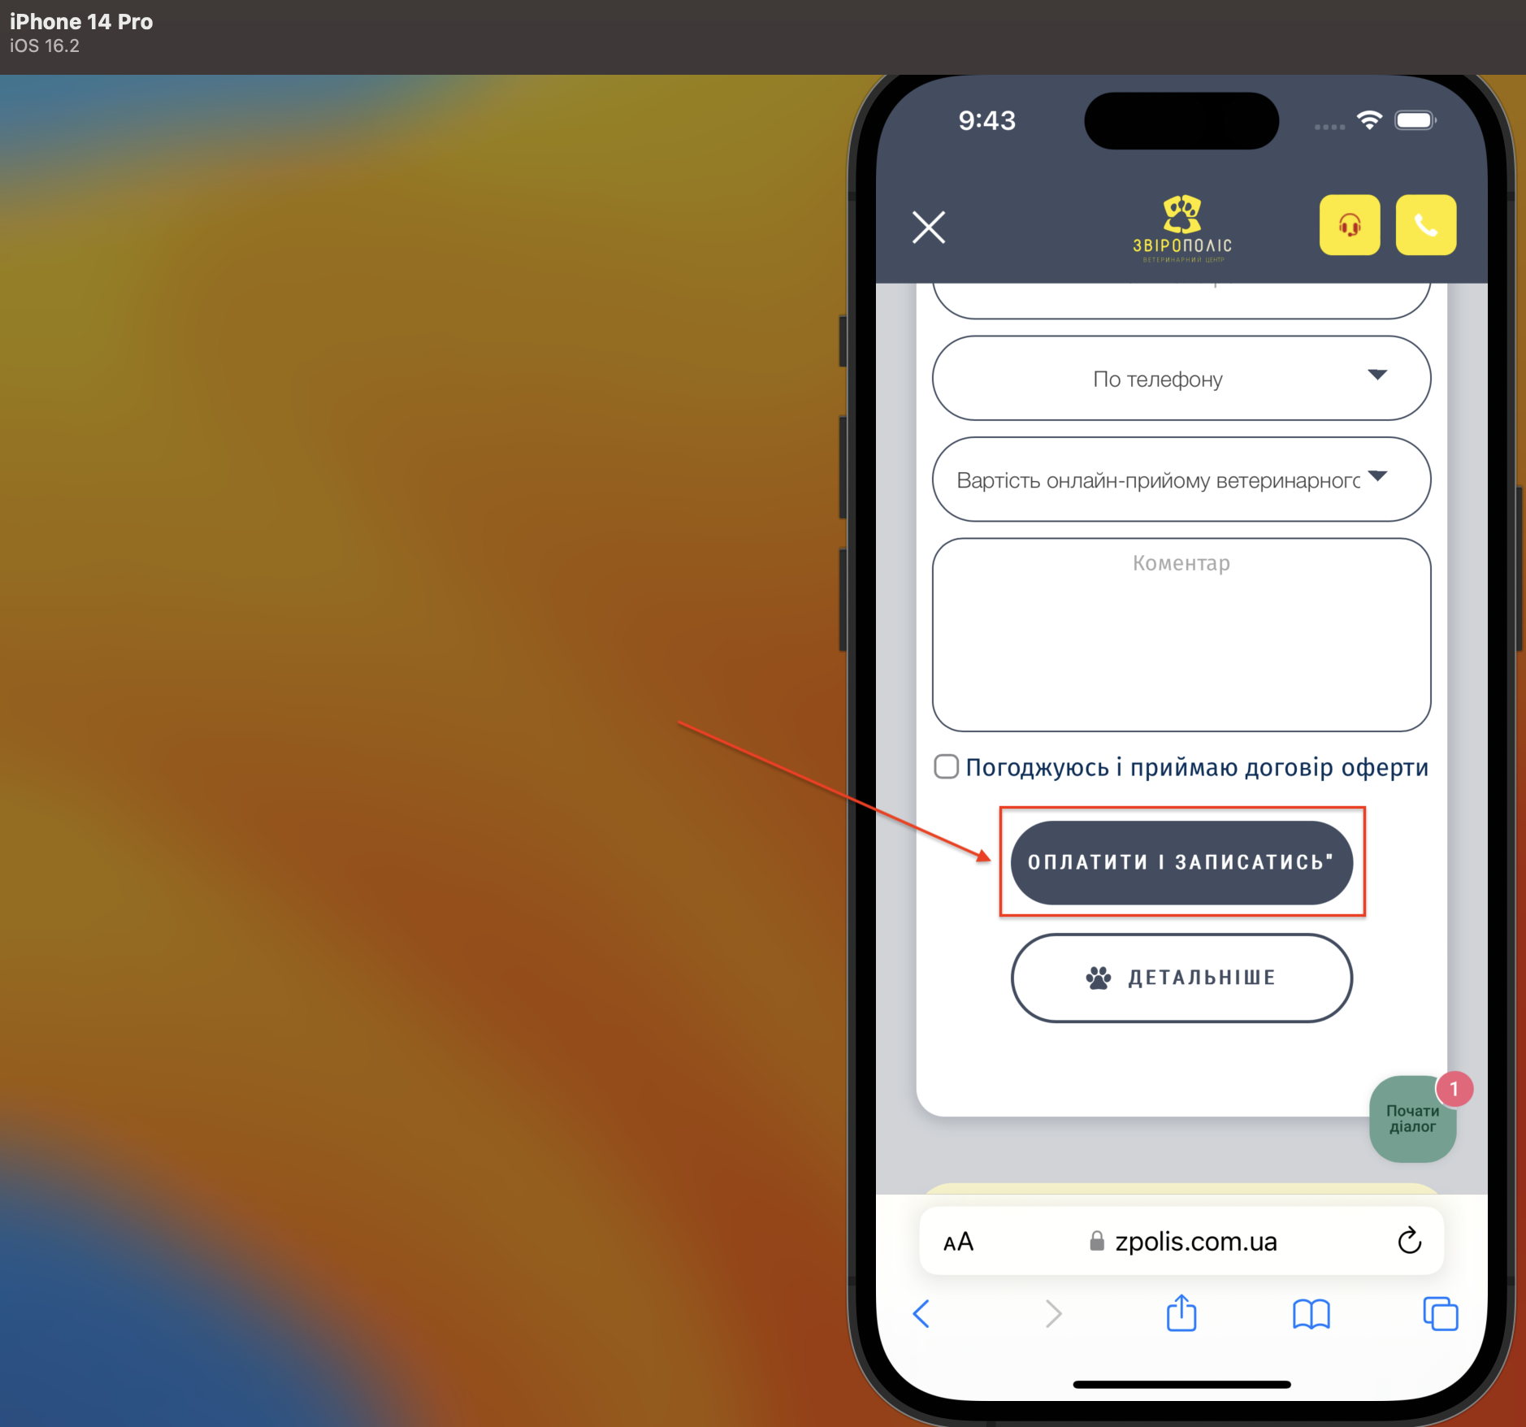

| Issue type | bug report 008 |
| --- | --- |
| Summary | Localisation. The content is not translated to the Ukrainian language. |
| Environment | Iphone 14 Pro (simulator) |
| Steps to reproduce | 1. Go to <https://zpolis.com.ua> 2. Press the sandwich menu in the header. 3. Choose “Готель для тварин” link. 4. Pay attention to the language of the page’s content |
| Actual result | The content is not translated to the Ukrainian language. |
| Expected result | The content must be translated to the Ukrainian language according to the localisation. |

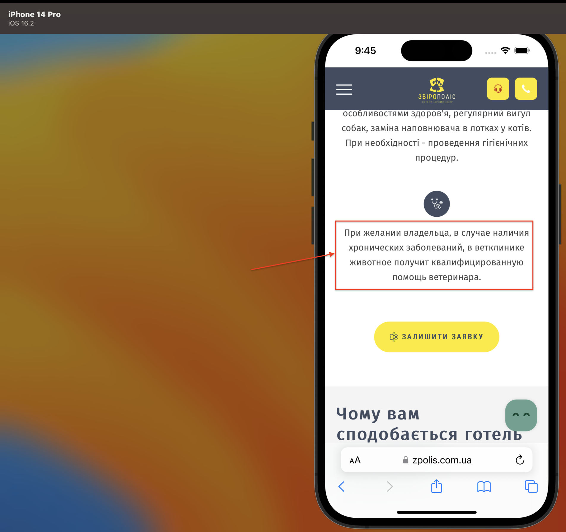

**Task 3**

Check list valid for users who have international passport, driver license, registered vehicle.

|  | Functional testing | Pass (P) /Fail (F) | Comment |
| --- | --- | --- | --- |
|  | **Menu Documents**   * Check international passport is displayed |  |  |
|  | * Check the QR code is visible   for the international passport |  |  |
|  | * Check the bar code is visible   for the international passport |  |  |
|  | * Check Driver license is displayed |  |  |
|  | * Check the QR code is visible   for the Driver license |  |  |
|  | * Check the bar code is visible   for the Driver license |  |  |
|  | Security testing |  |  |
|  | **Menu Documents**   * Check if the QR code is valid for the international passport after 3 min delay |  |  |
|  | * Check if the bar code is valid for the international passport after 3 min delay |  |  |
|  | * Check if the QR code is valid for the Driver license * after 3 min delay |  |  |
|  | * Check if the bar code valid for the Driver license after 3 min delay |  |  |
|  | Localization testing |  |  |
|  | **Menu “documents**   * check international passport translation |  |  |
|  | * check international Driver license translation |  |  |
|  | * check COVID certificate translation |  |  |
|  | * check vehicle registration   translation |  |  |
|  | * check   translation of the Child birth certificate |  |  |
| 1. 4 | Usability testing |  |  |
|  | **Menu “documents**   * Check the layout of the documents in the menu documents according to the original wireframe |  |  |
|  | * Check the display of “full information” of the international passport |  |  |
|  | * Check spelling of “full information” of the international passport |  |  |
|  | * Check the display of “full information” of the iDriver license |  |  |
|  | * Check spelling of “full information” of the Driver license |  |  |